**Meeting Minutes**

**Date:** February 16, 2020

**Time:** 05:00 PM

**Location:** Conference Room, 3rd floor

**Participants:**

1. ImrulHasan Sir
2. Akter Faruq Sir
3. Salauddin Sir
4. Mr. FarmanUllah
5. Mr. Pavel
6. Mr. Fahim Ahmed
7. Mr. Asaduzzaman
8. Shahadat Sir
9. Shukkur Sir

**Current System:**

**Oracle Server**

**OSDMS**

**OSDMS Web Application**

**MS SQL Server Database**

**Android Mobile App**

* All the information of OSDMS(Online Sales & Distribution Management System) are stored in a SQL Server
* Stock information is collected from oracle server
* Mobile app is used by SR and CM for providing sales and order information
* OSDMS web application is used in order to view order, sales & delivery information. Individual sales amount can also be viewed from here.
* Attendance of a sales person is calculated using their sales activity on a particular day.

Currently the following rules are used to calculate salary of a CM and SR

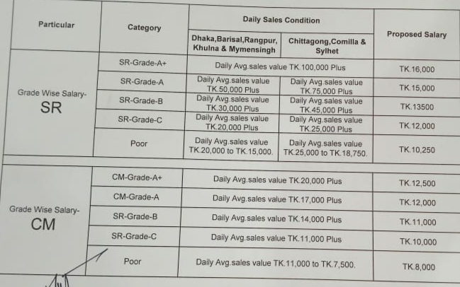

* When a new employee joins under a distribution center, a profile is created in OSDMS for that employee and all the information is sent to group HR. After that an employee profile is created after proper verification in oracle EBS by HR and employee id is updated in OSDMS according to oracle.
* Before creating profile in oracle, the employee has to complete a 3 month probation period.
* Currently for sales persons, professional skill is given more priority than educational qualification.
* There are more than 350 management employees and more than 5000 contractual employees there. Around 3000 contractual employees of them don’t have oracle id.
* As frequency of recruiting new employee is very high, HR department is facing difficulty to create employee profile in oracle in time.
* There are 13 divisions both in Oracle and OSDMS (Same division in both system, but there is spelling difference in the name of the divisions).
* Recently a huge number of customers are added in the system.
* Currently CGD has six business which are divided in two groups:  
  1. CPT (Condensed Milk, Powder Milk, Tea)

2. BSC (Beverage, Snacks, Candy)

* During calculation of salary for SR and CM, following factors will be considered
* 1. Loss of Pay  
  2. Incentive   
  3. Salary (Fixed, Variable).  
  4. KPI  
  5. Arrears  
  6. City Allowance  
  7. Territory Allowance

8. Working Day

* Trade price will be considered sales achievement.